CREATIVE EDUCATIONAL SERVICES
END OF TERM 2 EXAMINATIONS - 2024
PRIMARY THREE

MATHEMATICS

DURATION: 2 HOURS 30 MINUTES

Name _______________________________________ Stream __________
Date : ______________________________________

Read the following instructions carefully.
1. This paper has two Sections: A and B.

2. Section A has 20 answer questions (40 marks)

3. Section B has 12 questions (60 marks)

4. Answer ALL questions. Answers to both sections must be written in the spaces provided.

5. All answers must be written using a pencil. Diagrams should be drawn in pencil.

6. Unnecessary alteration of work may lead to loss of marks.

7. Any handwriting that cannot be easily read may lead to loss of marks.

8. Do not fill anything in the box indicated for examiner’s use only.

SECTION A (20 Questions - 40 marks)
- Add: 2 2  + 1 7 | - Which number comes after 65?
- Which number has been shown below?  = | - Work out;  7 1  – 4 5
- Which number has been shown on the abacus?  H T O | - Write in words.  165
- Tell the time.  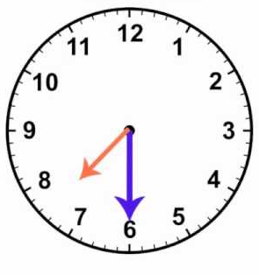  ______________ | - Change 4kgs to g.  (1 kg = 1000g)
- Shade 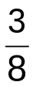 | - Name this set symbol.  _________________
- Add using the numberline.  4 + 3 = _________  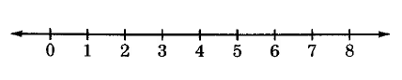 | 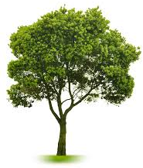  - If represents 5 trees. How many trees are represented by  Trees.
- If set A = { 0, 1, 2, 7, 5, 9, 3}. How many members are in set A? | - Write the place value of the circled number.  3 7 5
- One week has 7 days. How many days are in 3 weeks? | - Name the shapes.
- Set M and S are equal, find the  missing members in sets.  M S  93  60  0 ___  ___ 9 | - Work out :  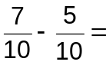
- Abba’s football field measured 10m long and 5 metres wide. Find its area. | - What number has been expanded  700 + 20 + 3
SECTION B
- Match correctly. (1 mark @)  - 10 + 5 5  - 10 ÷ 2 20  - 10 – 7 15  - 10 x 2 3 | - (a) Arrange these fractions from biggest to smallest. (2 marks)  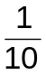 , , 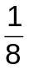  b) Work out: (2 marks)  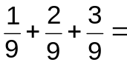  c) What fraction is unshaded?  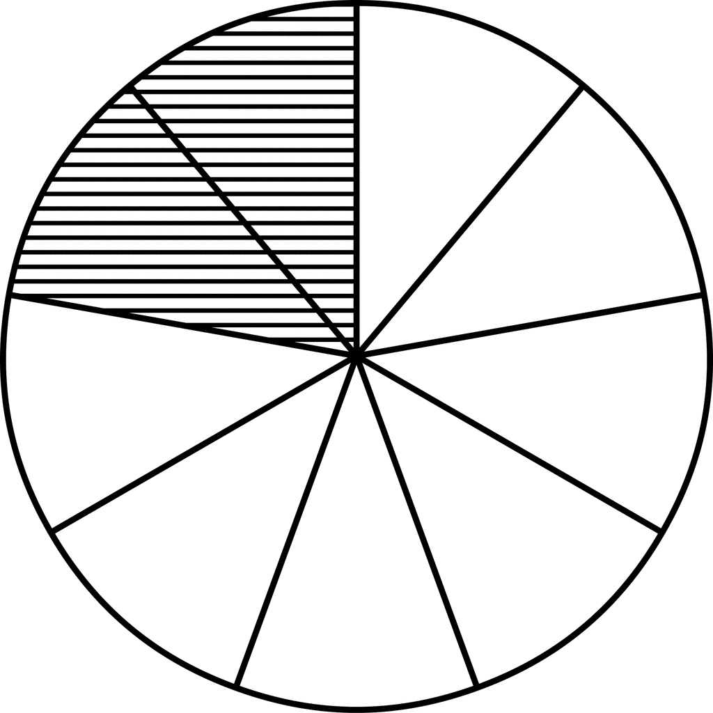  (2 marks)  =
- Write these numbers in Roman  Numerals. (2 marks @)  - 15 -  - Write XXV in Hindu Arabic numerals. | - a) Name the following geometrical  shapes. (1 mark @)  - (ii)  ________________ ______________  b) Draw the shapes.  i) Kite ii) Oval iii) Rectangle
- Given that    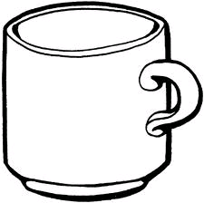  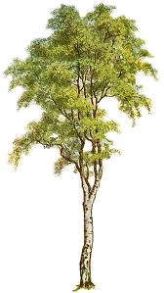  Set K = { , }  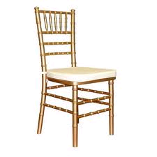  Set T = { , }  - Find K ∩ T. (1 mark)  - What is K ∪ T? (1 mark)  - Represent the information on a venn diagram. (3 marks)  K  T | - Coach Kisame bought these balls  for different games.  - Net ball 15 balls  - Football 20 balls  - Basket ball 3 balls  - How many balls did he buy for Netball and Basketball?  (2 marks @)  - How many more balls did he buy for football than Netball?  - How many balls were bought altogether?
- a) Find the perimeter of the  figure. (2 marks @)  3 dm  9 dm  b) How many triangles can you see?  c) If Musa walked from point A to c  via B.  A  B  C  5km  7km  What distance did he cover altogether? | - Mark went shopping for his trip  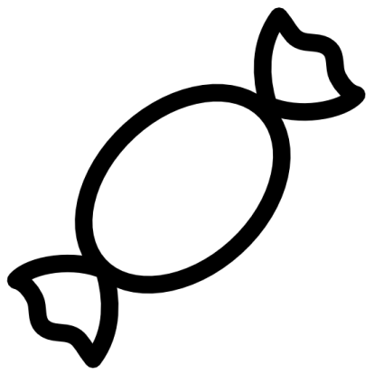  and bought the following;  sweets shs. 500  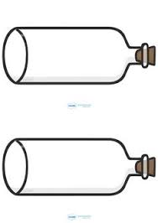  soda shs. 1000  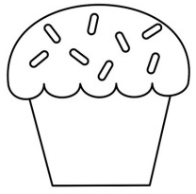  cake shs. 800  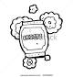  crisps shs. 300  - What is the most expensive item? (1 mark)  - How much is crisps? (1 mark)  - What is the cost of sweets and cake? (2 marks)  - Work out the difference between the price of a cake and the crisps. (2 marks)
- a) Show this time on the clock  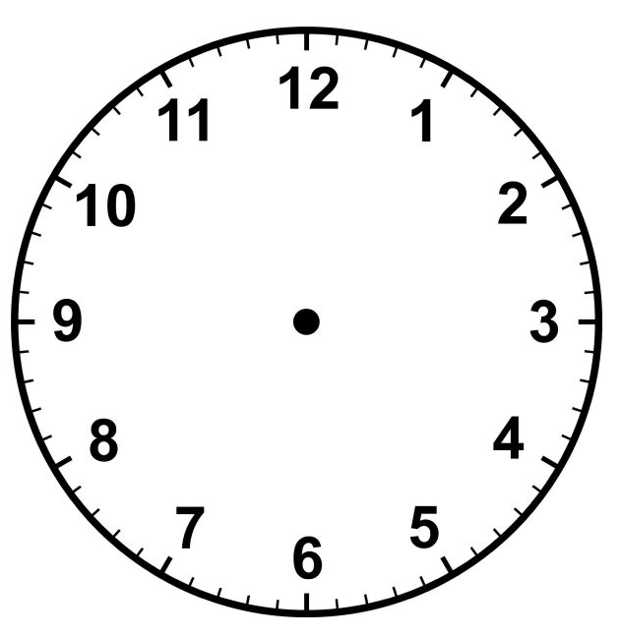  face 8:15 (1 mark)  b) Change 2 weeks to days.  (1 week = 7 days) (2 marks)  c) Work out (2 marks)  Hrs mins  5 32  + 2 25 | - a) One chair has 4 legs. How many  legs do 3 chairs have? (2 marks)  b) Joseph looked at himself in the mirror. How many boys did he see? (2 marks)
- Use > or < or = to complete the following. (1 mark @)
- 3 x 3 ________ 7 + 0

b) 5 + 5 _______ 18 – 8

c) 8 ÷ 2 ________ 2 + 6

- Using the graph below, answer the questions that follow;-
Eggs picked on Saturday
Joy | Luke | Tina | Mary

Questions
- On which day were the eggs picked? (1 mark)

- Who picked the least number of eggs? (1 mark)

- How many eggs did Joy and Mary pick? (2 marks)

- How many eggs were picked altogether? (2 marks)

